SQL INJECTION
Penetration Testing Assessment Report
PortSwigger Web Security Academy
Two controlled SQL injection exercises

Report attribute | Value
Assessment category | Web application security
Vulnerability class | SQL Injection — CWE-89
Testing tool | Burp Suite Community Edition
Assessment type | Manual testing in authorized training labs
Lab status | Both exercises successfully completed
CVSS version | CVSS v3.1 — indicative scores, not vendor-assigned
Prepared by | Joshua Jesuraj Sanctus
Date | 1 November 2026

CONFIDENTIALITY NOTE
This report documents educational testing against intentionally vulnerable PortSwigger environments. It does not describe an assessment of a production system.

1. Executive Summary
This assessment examined two SQL injection vulnerabilities in controlled PortSwigger Web Security Academy laboratory environments. The exercises demonstrate how unsafe handling of user-controlled input can alter SQL query logic, leading to unauthorized data retrieval or authentication bypass.
Two scenarios were completed:
- SQLi-01 — Manipulation of a product-category filter to achieve the lab's hidden-data retrieval objective.
- SQLi-02 — Manipulation of a login request to bypass authentication and reach the administrator account.
Both labs displayed a successful completion status. The screenshots and HTTP evidence supplied for this report are included in chronological order within the relevant findings.
The CVSS v3.1 scores below are illustrative estimates based on explicitly stated impact assumptions. They are not scores published by PortSwigger and should not be transferred to a real application without reassessment.

2. Scope and Methodology

2.1 Scope
Finding ID | PortSwigger lab | Testing objective
SQLi-01 | SQL injection vulnerability in WHERE clause allowing retrieval of hidden data | Alter category filtering and retrieve hidden records.
SQLi-02 | SQL injection vulnerability allowing login bypass | Manipulate authentication logic and access the administrator account.

2.2 Tools and environment
- Burp Suite Community Edition — intercepting and inspecting HTTP requests and responses.
- Web browser — interacting with the lab applications.
- PortSwigger Web Security Academy — intentionally vulnerable, authorized training targets.

2.3 Methodology
- Intercept normal application requests using Burp Suite.
- Identify parameters carrying user-controlled input.
- Modify the relevant parameter with a test SQL injection payload.
- Observe the application response and resulting behaviour.
- Verify the lab objective using the platform's completion status.
- Record evidence, assess potential impact, and recommend remediation.

3. Finding SQLi-01 — Hidden Data Retrieval
Attribute | Assessment
Vulnerability | SQL injection in a WHERE clause
Affected parameter | category
Affected functionality | Product category filtering
CWE | CWE-89 — Improper Neutralization of Special Elements used in an SQL Command
CVSS v3.1 | 5.3 — Medium (indicative)
Lab result | Solved

3.1 Description
The product listing functionality accepts a category parameter. The lab demonstrates that the parameter can be manipulated to alter the logic of the underlying database query. The supplied condition is intended to make the filtering predicate evaluate as true, thereby bypassing the intended category restriction and allowing hidden product records to be retrieved.

3.2 Identification and test input
A normal category-filter request was first observed in Burp Suite Proxy. The category parameter was then modified.
GET /filter?category=' OR 1=1-- - HTTP/2
Test payload:
' OR 1=1-- -

3.3 Technical analysis
A simplified example of an unsafe query pattern is shown below. This is an illustrative reconstruction, not verified application source code.
SELECT *
FROM products
WHERE category = '<user_input>'
AND released = 1;
If untrusted input is concatenated directly into a SQL statement, SQL syntax supplied by the user may change the query's structure. In this example, the quote attempts to terminate the string value, OR 1=1 introduces an always-true predicate, and the comment marker attempts to disregard the remainder of the statement. The precise behaviour depends on the database engine and the original query.

3.4 Evidence and observations
The supplied evidence shows the intercepted category request, the injected parameter, the HTTP response, the reflected input in the returned HTML, and the lab completion status.
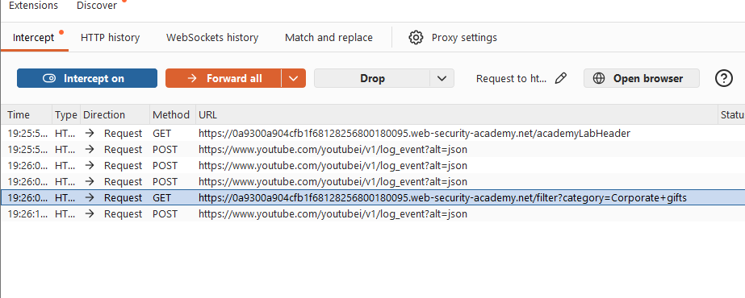
Figure 1. Burp Suite Proxy history showing category-filter traffic.
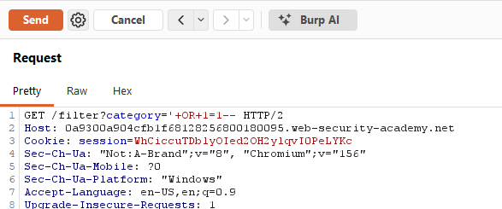
Figure 2. Intercepted category request containing the SQL injection input.
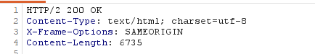
Figure 3. HTTP response status and headers: HTTP/2 200 OK.
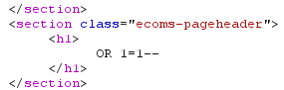
Figure 4. Returned HTML reflects the supplied value in the page heading.
Evidence limitation: the supplied HTML excerpt contains an empty product-tile container. The reflection of the payload and HTTP 200 response do not independently prove SQL execution or show the retrieved records. The PortSwigger lab's solved status confirms that the lab objective was completed; the report does not treat the reflected heading as standalone proof of database output.
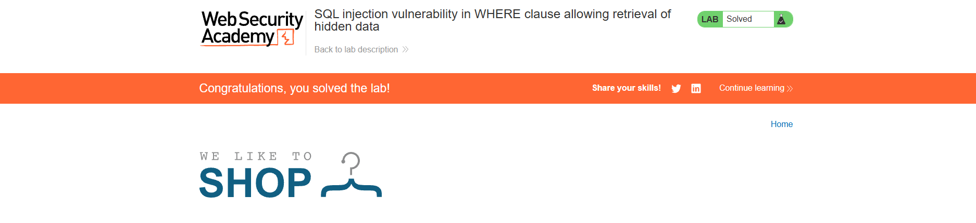
Figure 5. PortSwigger Web Security Academy confirms that the hidden-data retrieval lab is solved.

3.5 Potential security impact
- Unauthorized retrieval of records that should be excluded by application-level filtering.
- Disclosure of business or customer information, depending on the records exposed and database permissions.
- Information gathering that may support further attacks.
The actual impact in a production environment would depend on the data returned, its sensitivity, and the privileges of the application's database account.

3.6 Indicative CVSS v3.1 assessment
Score: 5.3 — Medium
CVSS:3.1/AV:N/AC:L/PR:N/UI:N/S:U/C:L/I:N/A:N
Metric | Value | Rationale
Attack Vector | Network | The vulnerable parameter is submitted over HTTP.
Attack Complexity | Low | No special preconditions are assumed.
Privileges Required | None | The lab scenario is accessible without prior authentication.
User Interaction | None | No separate victim action is required.
Scope | Unchanged | The assumed impact remains within the vulnerable application.
Confidentiality | Low | Limited disclosure is assumed.
Integrity | None | No modification of data is demonstrated.
Availability | None | No service disruption is demonstrated.

Scoring assumption: the rating assumes limited confidentiality impact because the exercise concerns hidden product records. A production system exposing sensitive or extensive data could warrant a higher confidentiality impact and a different score.

3.7 MITRE ATT&CK mapping
T1190 — Exploit Public-Facing Application: potentially applicable where an attacker exploits an exposed web application vulnerability to gain an initial foothold.
T1213 — Data from Information Repositories: a possible follow-on behaviour if an attacker uses the vulnerability to collect information from a database. This is not a direct technique identifier for SQL injection itself.

3.8 Remediation
- Use parameterized queries or prepared statements so user input is treated as data, not executable SQL syntax.
- Avoid constructing SQL statements by concatenating untrusted input.
- Validate category values against an allowlist of valid categories.
- Apply least-privilege permissions to the application's database account.
- Return generic application errors and avoid exposing database details.
- Include SQL injection tests in development, code review, and security testing.
Illustrative parameterized-query pattern (placeholder syntax varies by database driver):
cursor.execute(
"SELECT * FROM products WHERE category = %s AND released = 1",
(category,)
)

4. Finding SQLi-02 — Authentication Bypass
Attribute | Assessment
Vulnerability | SQL injection in authentication logic
Affected parameters | username; password
Affected functionality | User login
CWE | CWE-89 — Improper Neutralization of Special Elements used in an SQL Command
CVSS v3.1 | 9.1 — Critical (indicative)
Lab result | Solved

4.1 Description
The login functionality accepts username and password values. The lab demonstrates that manipulating the username parameter can alter the logic of the underlying authentication query. The resulting request bypasses the password check and grants access to the administrator account.

4.2 Identification and test input
The original login request was intercepted using Burp Suite. The username and password parameters were visible in the form submission.
username=test&password=test
The username value was then modified using the following test payload:
administrator'--

4.3 Technical analysis
A simplified example of a vulnerable authentication query is shown below. This is an illustrative reconstruction, not verified application source code.
SELECT *
FROM users
WHERE username = '<username>'
AND password = '<password>';
If the username is inserted directly into the query, the supplied quote may terminate the username string and the comment marker may cause the remaining password condition to be ignored. This can cause the query to return the administrator record without validating the legitimate password. The precise effect depends on the original query and database syntax.

4.4 Evidence and observations
The screenshots show the original login request, the modified request/response in Burp Suite, the redirect to the administrator account, and the lab completion status.
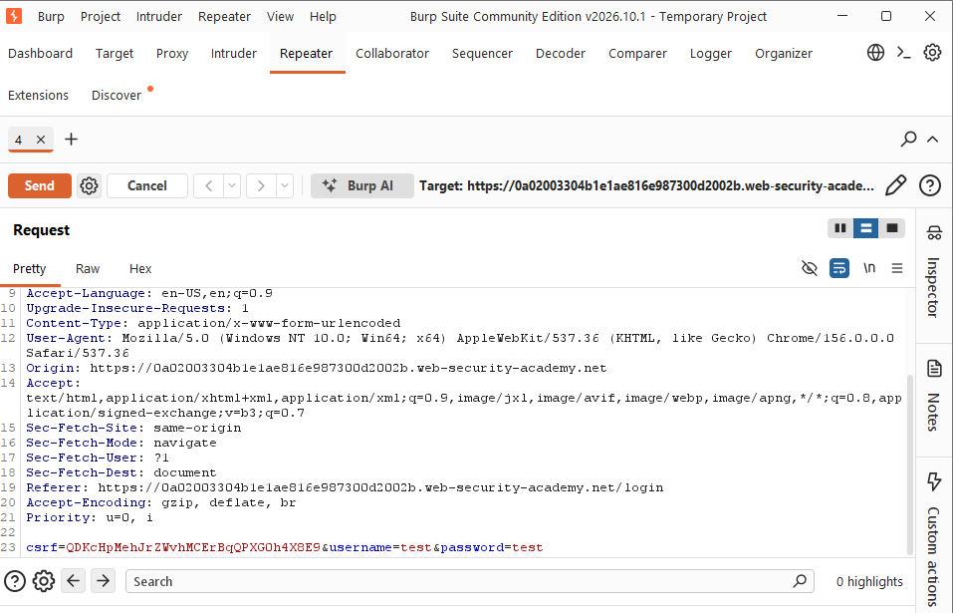
Figure 6. Original login request intercepted in Burp Suite.
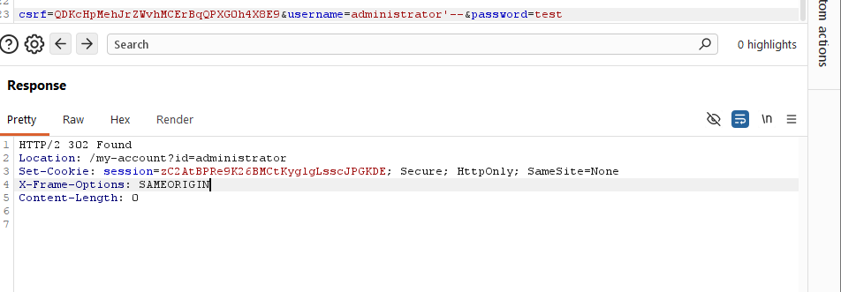
Figure 7. Modified authentication request and response showing the administrator account redirect.
The response included the following redirect:
HTTP/2 302 Found
Location: /my-account?id=administrator
The redirect is consistent with successful authentication into the administrator account. The PortSwigger completion indicator confirms that the lab's authentication-bypass objective was achieved.

Figure 8. PortSwigger Web Security Academy confirms that the login-bypass lab is solved.

4.5 Potential security impact
- Unauthorized access to administrator functionality.
- Exposure of information accessible to the compromised account.
- Unauthorized modification of application data or settings where administrator permissions allow it.
- Further compromise of the application through privileged functionality.
The extent of impact depends on the actual permissions of the administrator account and the controls protecting administrative operations.

4.6 Indicative CVSS v3.1 assessment
Score: 9.1 — Critical
CVSS:3.1/AV:N/AC:L/PR:N/UI:N/S:U/C:H/I:H/A:N
Metric | Value | Rationale
Attack Vector | Network | The attack is performed through the web login interface.
Attack Complexity | Low | No special preconditions are assumed.
Privileges Required | None | The attacker does not need an authenticated account.
User Interaction | None | No separate victim action is required.
Scope | Unchanged | The assumed impact remains within the vulnerable application.
Confidentiality | High | Administrator access is assumed to expose sensitive application data.
Integrity | High | Administrator access is assumed to permit significant data or configuration changes.
Availability | None | No availability impact is demonstrated.

Scoring assumption: the 9.1 score depends on assuming that the administrator account provides broad confidentiality and integrity impact. The lab demonstrates authentication bypass, but does not independently establish the full impact of a real production administrator account. Recalculate the score for the actual target environment.

4.7 MITRE ATT&CK mapping
T1190 — Exploit Public-Facing Application: applicable as a broad mapping when an attacker exploits a vulnerability in an externally accessible application. SQL injection is the exploitation method; ATT&CK does not provide a dedicated technique specifically for SQL injection-based authentication bypass.

4.8 Remediation
- Use parameterized queries for all authentication-related database operations.
- Retrieve the account record using a parameterized username query, then verify the submitted password using a secure password-hashing function.
- Do not store plaintext passwords; use a dedicated password-hashing algorithm such as Argon2id, bcrypt, or scrypt.
- Apply least privilege to application and database accounts.
- Enforce server-side authorization checks for every privileged operation.
- Use multi-factor authentication for privileged accounts as an additional security layer.
- Monitor authentication events for unusual access patterns and repeated failures.

5. Comparative Analysis
Attribute | SQLi-01 | SQLi-02
Affected functionality | Product filtering | Authentication
Input parameter | category | username
Primary objective | Retrieve hidden records | Bypass login
Demonstrated outcome | Lab hidden-data objective completed | Administrator login-bypass objective completed
CVSS v3.1 estimate | 5.3 — Medium | 9.1 — Critical
CWE | CWE-89 | CWE-89
ATT&CK mapping | T1190; possible follow-on T1213 | T1190

Both findings arise from unsafe handling of user-controlled input in SQL statements. Their consequences differ: SQLi-01 concerns unauthorized data retrieval through a filtering function, while SQLi-02 concerns compromise of an authentication boundary. Severity should therefore be based on demonstrated and reasonably supported impact, not solely on the vulnerability name.

6. Conclusion
The two PortSwigger exercises successfully demonstrated distinct consequences of SQL injection: retrieval of hidden data and authentication bypass. The assessment highlights the importance of parameterized queries, secure authentication design, least-privilege database permissions, and server-side authorization controls.
The exercises also demonstrate the importance of evidence-based reporting. HTTP status codes and reflected input are useful observations, but they should not be overstated as proof of database execution. Lab completion status and the observed authentication redirect provide additional evidence for the respective objectives.

7. References
- PortSwigger Web Security Academy — SQL Injection
https://portswigger.net/web-security/sql-injection
- PortSwigger — Hidden Data Retrieval Lab
https://portswigger.net/web-security/sql-injection/lab-retrieve-hidden-data
- PortSwigger — Login Bypass Lab
https://portswigger.net/web-security/sql-injection/lab-login-bypass
- FIRST — CVSS v3.1 Specification
https://www.first.org/cvss/v3.1/specification.document
- MITRE ATT&CK — T1190: Exploit Public-Facing Application
https://attack.mitre.org/techniques/T1190/
- MITRE ATT&CK — T1213: Data from Information Repositories
https://attack.mitre.org/techniques/T1213/
- MITRE CWE — CWE-89
https://cwe.mitre.org/data/definitions/89.html
- OWASP — SQL Injection Prevention Cheat Sheet
https://cheatsheetseries.owasp.org/cheatsheets/SQL_Injection_Prevention_Cheat_Sheet.html

